MATERNITY ALLOWANCE JOURNEY

Common Services / Objectives / Bullet Points

- Accelerated Decision Making
- Smarter Payments
- Accurate Signposting
- Self-Service
- Identifying Citizens Effectively
- Joined Up & Trusted Data
- Understanding Circumstances
- Life Events Fed Into Process

 1.

Jane, is an expectant mother who recently started a new role. Unfortunately, she is not entitled to Statutory Maternity Pay through her employer.

One day after work, one of her colleagues who previously received support from the DWP signposts Jane to GOV.UK to find out what she may be entitled to.

- Accurate Signposting. Signposting isn’t an activity restricted to DWP colleagues. Friends, family and other organisations routinely signpost citizens to our services. Gateways like GOV.UK take the strain off busy telephony lines and empowers citizens to find and engage with the support they need.

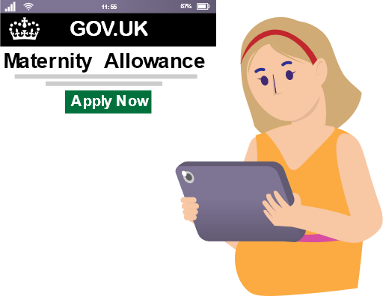2.
Jane uses her tablet to access GOV.UK to find out what benefit’s she’s eligible for. Clear, concise instructions online explain the claim process and her responsibilities. After reviewing the guidance, Jane has the option to apply online straight away.

- Self-Service. Jane submits her claim online during a work break and sets her preferred channel for notifications about her claim. For a long time, the DWP has sent letters and notifications via the post, which is time-consuming, costly and can delay our decision-making as we wait for a response from the citizen.

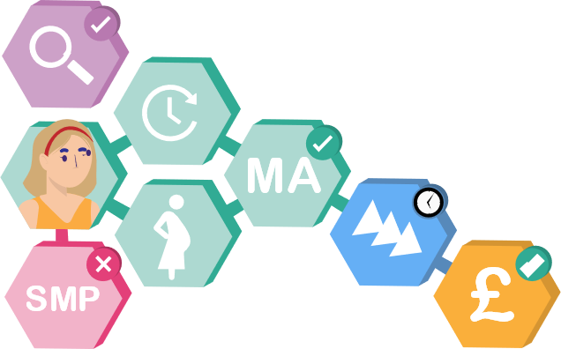3.

The DWP begin to process the claim immediately.

- Identifying Citizens Effectively. We’re able to effectively identify the citizen using our robust identity verification technology.

- Joined Up & Trusted Data. Our trusted data suppliers such as HMRC and the NHS can provide information, evidence, and insights that enable us to make informed decisions, as well as confirm information directly with our suppliers without asking the citizen to send in evidence.

- Accelerated Decision Making. Because we can confirm information using our trusted data suppliers, we can deliver faster, streamlined decisions that are more-automated.

- Smarter Payments. As a result of being able to confirm citizen information automatically,

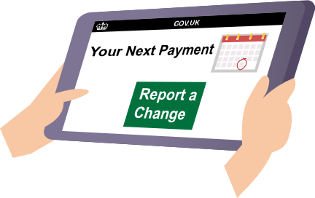4.

The DWP confirm the claim and commence making regular payments. We notify Jane immediately via her preferred communication channel. Now that her claim is setup, she can access her claim information online.

- Self-Service. Currently, Jane can see when her next payment is due as well as how much it will be. She can also report a change to the Department instantly. A common question that most DWP telephony lines receive from citizens is ‘when will I get paid?’ We can empower citizens by providing this information to them online.
Jane now has the capability, access, and knowledge to self-manage her circumstances online.

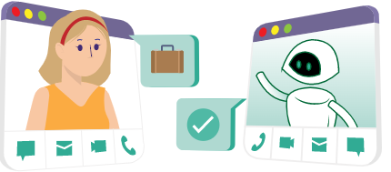5.
After some time, the DWP sends Jane a message via her preferred channel to remind her that the claim will automatically cease after 39 weeks. Prompted by the reminder, Jane starts to plan for an early return to work.

- Self-Service. Jane notifies the DWP of her intent to close her claim early via one of our self-service chatbots.

We automatically update Jane’s claim, ceasing any further payment and closing the claim.
5 Alternative.

After some time, Jane decides to use her Keeping In Touch Days to ease herself back into the workplace.

- Joined Up & Trusted Data Because the DWP can rely on information from our suppliers such as HMRC, who can provide us with information about Jane’s earnings, we know about Jane’s Keeping In Touch days automatically, and can update her claim accordingly.
We automatically update Jane’s claim, without having to request evidence from the citizen.

6.

Jane’s claim has now been closed (either because she asked for it, or because it ceased automatically after 39 weeks. Depends on which version of panel 5 is used). Jane returns to her previous employment.

- Joined Up & Trusted Data Because the DWP re-uses data where possible, we keep only the relevant and necessary information that will make it easier for Jane and her child to claim in the future.
- Accurate Signposting. Because Jane’s experience was straight forward, streamlined and easy to manage, Jane is more likely to recommend and signpost other citizens to DWP services herself.

